**ACTIVITY 1**

**Individual work !**

1. Draw the DOM tree for the HTML code below :

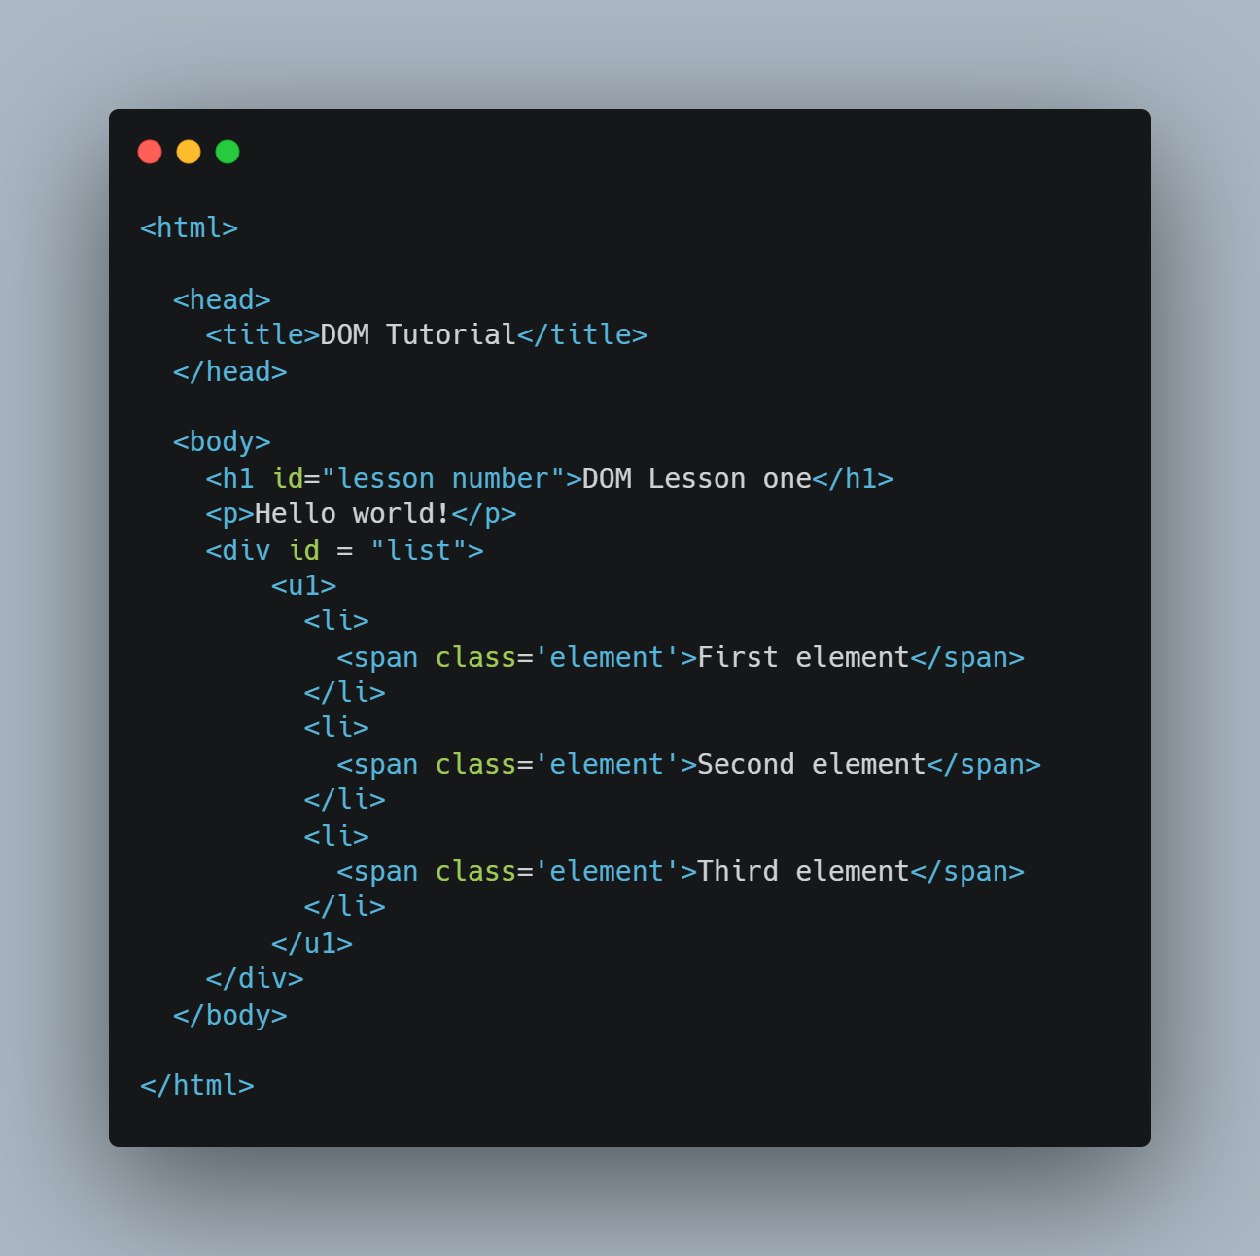

1. **Answer the questions :**

|  |  |
| --- | --- |
| How many **children** does the <h1> node have | It has no children. |
| How many **children** does the <head> node have | It has 2 children. |
| How many **siblings** does the first <li> node have | There 3 siblings of li. |
| Who is the **parent** of the second <span> node | li (second element). |
| Who is the **parent** of the <ul> node | div with id “list” is the parent of the <ul>. |
| Who is the **first child** of the <body> node | <h1> is the first child of the <body> . |
| How many **children** does the <body> node have | The body node has 3 children. |
| How many **siblings** does the <u1> sibling have | It has no sibling. |
| What is the **root** **node** does it have parents | Root node is <html> tag. |